South Australia
Bills of Sale Act 1886
An Act to provide for the registration of bills of sale; to provide for the form and content of bills of sale; and for other purposes.

Contents
Part 1—Preliminary
1 Short title
2 Interpretation
Part 2—Form and contents of bills of sale
7 Form of bill of sale
8 Bill of sale to have effect of a deed
9 Contents of bill of sale
10 Property assignable
10A Assignments of future crops
11 Covenants and powers implied in bills of sale
11A Standard terms and conditions in bills of sale
12 Implication of certain words
12A Joint and several liability under bill of sale
12B Joint and several entitlement of grantees
13 Witnesses
Part 3—Registration of bills of sale and other dealings
15 Bill of sale to be registered in General Registry Office
17 Bill of sale to be registered
17A Successive bills of sale
17B Power of Court to extend time for registration
18 Bills of sale to be registered in order of production
19 Bills of sale, how to be registered
19A Renewal of registration of bills of sale
19B Power of Court to extend time for renewal
19D Destruction of old bills of sale
19E Bills of sale registered after expiry of registration of prior bill of sale
20 Form of transfer of bill of sale
21 Bill of sale may be extended, varied or corrected
22 Discharge
23 Registration of dealings with registered bills of sale
24 Index to be kept by Registrar
25 Omissions and errors in the registry may be corrected
26 In case of variance, original to prevail
27 Search allowed
Part 4—Disposition of chattels in case of insolvency or distress
28 Bills of sale to be void in certain circumstances
29 Bill of sale valid security for further advance
30 Distress for rates may be levied on goods comprised in bill of sale
31 Distress not to be levied against goods in bill of sale except for a limited amount
Part 6—Miscellaneous provisions
34 Fees
36 Goods not to be sold until five days after seizure
37 Fraudulently disposing of goods
38 False declaration to be perjury
38A Paper to be used for instruments
38B Minister may discharge bill of sale in certain circumstances
39 Regulations
41 Act not to apply to chattels taken and kept by grantee within 21 days
Part 7—Provisions relating to PPS Act
42 Certain provisions of Act to cease to have effect
43 Provision of information to Commonwealth
44 Immunity
45 Registrar may refuse to exercise functions
46 Registrar may dispose of certain documents
47 Regulations
Part 8—Repeal of Act
48 Repeal of Act
Schedule 1—Bill of sale
Schedule 3—Certificate of registration to be endorsed by Registrar on each bill of sale
Schedule 4—Discharge of bill of sale
Schedule 5—Transfer of bill of sale
Legislative history
Appendix—Divisional penalties and expiation fees

The Parliament of South Australia enacts as follows:
Part 1—Preliminary
1—Short title
This Act may be cited as the Bills of Sale Act 1886.
2—Interpretation
(1) In this Act, unless the contrary intention appears—
bill of sale includes bills of sale, assignments, transfers, declarations of trust without transfer, inventories of goods with a receipt for the goods attached, or receipts for purchase-money of goods and other assurances of personal chattels, and also powers of attorney, authorities, or licences to take possession of personal chattels as security for any debt, and also any agreement, whether intended or not to be followed by the execution of any other instrument by which a right in equity to any personal chattels, or to any charge or security on personal chattels is conferred, but does not include the following documents: Assignments for the benefit of creditors made pursuant to any statutory provision, marriage settlements, transfers or assignments of any ship or vessel, or any share of a ship or vessel, stock mortgages, agreements conferring a preferable lien on wool, transfers of goods in the ordinary course of business of any trade or calling, bills of sale of goods in foreign parts or at sea, bills of lading, warehouse-keepers' certificates, dock warrants, warrants or orders for the delivery of goods, or any other documents used in the ordinary course of business, as proof of the possession or control of goods, or authorising or purporting to authorise, either by endorsement or by delivery, the possessor of such document, to transfer or receive goods referred to in the document;
business day means any day except a Saturday or a Sunday or other public holiday;
contemporaneous advance includes as well as a contemporaneous advance of money by the grantee to the grantor the sale of goods or property upon credit, or the drawing, accepting, endorsing, making or giving of any bill of exchange, promissory note, or guarantee, or other matter or thing by the grantee to, for, or on behalf of the grantor on the security of any bill of sale, and contemporaneously with the giving thereof;
dealing with a bill of sale means transfer, assignment, extension, variation, correction or discharge of the bill of sale;
grantee means the person to whom a bill of sale is given, and includes his or her executors, administrators, and assigns and where the grantee is a body corporate the term includes the successors in title of that body corporate;
grantor means the person giving the bill of sale, and includes his or her executors, administrators, and assigns and where the grantor is a body corporate the term includes the successors in title of that body corporate;
personal chattels means horses or cattle, furniture, goods, chattels, and other articles capable of complete transfer by delivery, and (when separately assigned or charged) fixtures or growing crops; but does not include chattel interests in real estate, nor fixtures (except trade machinery), when assigned together with a freehold or leasehold interest in any land or building to which they are affixed, nor growing crops when assigned together with any interest in the land on which they grow, nor debentures, shares, or interests in the stock, funds, or securities of any government, or in the capital or property of any company, nor choses in action; nor sheep, pigs, goats, camels, mules, or donkeys, nor wool on the sheep's back, nor more than ten horses or more than ten head of cattle belonging to one owner;
PPS Act means the Personal Property Securities Act 2009 of the Commonwealth;
Registrar means the Registrar-General;
registration commencement time has the same meaning as in the PPS Act;
registry means the General Registry Office;
trade machinery means the machinery used in or attached to any factory or workshop.
(2) Fixtures and growing crops will not be taken to be separately assigned or charged by reason only that they are assigned by separate words, or that power is given to sever them from the land or building to which they are affixed, or from the land on which they grow, if by the same instrument any freehold or leasehold interest in the land or building to which such fixtures are affixed, or in the land on which such crops grow, is also conveyed, mortgaged, or assigned to the same persons or person.
Note—
For definition of divisional penalties (and divisional expiation fees) see Appendix.

Part 2—Form and contents of bills of sale
7—Form of bill of sale
Every bill of sale, the registration of which is necessary, must be executed in duplicate, and may be in the form in Schedule 1.
8—Bill of sale to have effect of a deed
Every bill of sale, when registered, has the effect of, and will be taken to be, a deed duly executed by the parties who have signed it.
9—Contents of bill of sale
(1) Every bill of sale must contain or state—
(a) the names of the grantor and grantee, their residences or places of business and occupations; but it will be sufficient to state the names by which the grantor or grantee are usually known, and, in the case of a corporation, it will be sufficient to state the corporate name, with the place or one of the places where the business of the corporation is usually carried on;
(b) the name, place of residence or business, and occupation of every attesting witness.
(2) A bill of sale must not be registered unless it contains the particulars required by subsection (1).
10—Property assignable
(1) The classes of property referred to in paragraphs (a) and (b) may be assigned by bill of sale, and will be taken to have been assigned at law as well as in equity:
(a) crops (separately assigned) growing at the time of the execution of the bill of sale, but without prejudice to the rights of a genuine purchaser or mortgagee of the land on which the crops are growing;
(b) the progeny coming into existence during the operation of any bill of sale of any horses or cattle comprised in the bill of sale.
(2) The assignment by bill of sale of all other after-acquired property has, subject to the other provisions of this Act, the same effect as before the passing of The Bills of Sale Act 1885.
10A—Assignments of future crops
(1) Notwithstanding any enactment or rule of law to the contrary, any document executed before the registration commencement time that complied with this Act at the time of its execution, under which any person purports to assign separately whether absolutely or by way of security any crops to be grown by the assignor or on the assignor's behalf within 12 months after the execution of the document on land described in the document is a bill of sale within the meaning of this Act, and will operate to assign the ownership at law as well as in equity of the crops, but without prejudice to the rights of a genuine purchaser or mortgagee of the land on which the crops grow.
(2) Crops referred to in subsection (1) are personal chattels within the meaning of this Act and a bill of sale relating to any such crops must state their nature and describe the land on which they are intended to be grown.
11—Covenants and powers implied in bills of sale
The following covenants and powers will, unless negatived and subject to any modification, be implied in favour of the grantee and as to paragraph (h) as an agreement between the parties in every bill of sale for securing money executed before the registration commencement time:
(a) the grantor will pay to the grantee the principal and interest money secured, or intended to be secured, by the bill of sale, at the time and in the manner provided for payment in the bill of sale;
(b) the grantor will not, without the consent in writing of the grantee, sell, exchange, or fraudulently remove the personal chattels comprised in the bill of sale from the premises mentioned in the bill of sale, and will at all times keep the personal chattels in good order and condition;
(c) the grantor will not permit the personal chattels comprised in the bill of sale to be distrained for any rent, rates, or taxes, nor permit any execution to be levied against his or her goods or chattels, nor become insolvent, call a meeting of his or her creditors, or make any statutory assignment for the benefit of his or her creditors;
(d) the grantor will produce to the grantee, upon demand, the last receipt for all rent, rates, and taxes in respect of the premises at which the personal chattels are situated;
(e) the grantee or the grantee's agents, may, at all reasonable times, enter upon the grantor's premises at which the personal chattels are kept, and view their state and condition, and the grantor will produce to the grantee or the grantee's agents the personal chattels comprised in the bill of sale, and permit the grantee or the grantee's agents to take an inventory of them;
(f) if the grantor makes default in the payment of the principal or interest money secured by the bill of sale at the time provided for payment, or in the observance or performance of any one of the covenants, terms, conditions, or agreements, whether expressed or implied, in the bill of sale, it will be lawful for the grantee, without any further consent or concurrence on the part of the grantor, to enter into and upon the land, messuage, or tenement on which the personal chattels assigned are, or into or upon any other land, messuage, or tenement on or in which the personal chattels, or any other personal chattels comprised and included in the bill of sale respectively, may be, or may reasonably be supposed to be, and for that purpose to open or remove any outer or inner gate, door, fastening, or other obstruction, without liability to any action of trespass, or other proceeding for so doing; but with liberty to plead the leave and licence given in bar to any such action or proceeding, if any such be brought or instituted, and to seize and take possession of all such personal chattels, and to remove them to any other place or places for safety, convenience of sale, or for any other purpose, or permit them to remain in the place or places where they may be found, and to sell and dispose of such chattels and premises, or any of them, either together or in parcels, at such time or times, and place or places, and either by public auction or private contract, or partly by public auction and partly by private contract, to any person or persons, for such price or prices, either for cash or on credit, or partly for cash and partly on credit, and if either wholly or partly on credit, giving such time or times for payment, and taking or foregoing any security or securities for the payment of the unpaid purchase-money as the grantee may deem proper or expedient, with power for the grantee to make any other terms and conditions in regard to such sale or sales as the grantee may think proper, and also to buy in all or any of the chattels at any such sale or sales by auction, and rescind or vary any contract for sale, and again to resell or offer for resale the chattels from time to time, without being answerable or accountable for any loss, diminution in price, costs, or expenses to be occasioned by any such buying in, rescission, variance, or actual or attempted resale;
(g) it will be lawful for the grantee, upon or after any such sale, to execute any contract or other document that is necessary or expedient for the purpose of making and effecting any such sale, and which will be as binding and conclusive upon and against the grantor as if the grantor had executed it. And also that the receipt or receipts in writing of the grantee for all purchase-money or other property which is paid or delivered to the grantee under or by virtue of the bill of sale, will be a good and sufficient discharge or good and sufficient discharges to all purchasers or other persons paying or delivering the same, and that the purchaser or other persons will not be required to see the application, or be answerable for the misapplication or nonapplication of the purchase-money or other property, or be bound or concerned to inquire into the propriety or expediency of any such sale or resale;
(h) the grantee will out of the money which comes to the grantee's hands by reason of any such sale or sales, in the first place, discharge the costs and expenses incurred or sustained in or about such sale or sales, and all other costs, charges, and expenses incurred or occasioned in or about the execution of the powers and authorities contained in the bill of sale, and retain the balance of the money, or so much of it as may be necessary, in or towards payment and satisfaction of all money due and owing to him or her upon the security of the bill of sale, and the grantee will pay to the grantor the surplus then remaining.
11A—Standard terms and conditions in bills of sale
(1) Subject to subsection (1a), a person may deposit with the Registrar for filing in the General Registry Office a document containing terms and conditions for incorporation as standard terms and conditions in bills of sale under this section.
(1a) A document of a kind referred to in subsection (1) cannot be deposited with the Registrar following the last business day before the registration commencement time.
(2) A bill of sale executed before the registration commencement time may provide that standard terms and conditions, as contained in a document filed by the Registrar in the General Registry Office under subsection (1)—
(a) are incorporated in the bill of sale; or
(b) are incorporated in the bill of sale subject to exclusions or amendments specified in the bill of sale,
and, in that event, the bill of sale has effect as if those terms and conditions were (subject to any exclusions or amendments specified in the bill of sale) contained in the bill of sale.
(3) Where a bill of sale makes provision for incorporation of standard terms and conditions (either with or without exclusions or amendments), the grantee must, before execution of the bill of sale by the grantor, provide the grantor with a copy of the standard terms and conditions.
Penalty: Division 9 fine.
(4) Non-compliance with subsection (3) does not affect the validity or effect of a bill of sale.
12—Implication of certain words
The words "that the grantor will insure" in any bill of sale executed before the registration commencement time imply that the grantor will immediately insure and, so long as any money remains due on the security of the bill of sale, keep insured in some public insurance office, to be approved of by the grantee, against loss or damage by fire, in the name of the grantee, the personal chattels comprised in the bill of sale to the full amount secured by the bill of sale, and will hand over to the grantee the policy of insurance and produce to the grantee the receipts for the annual or other periodical premiums payable on account of insurance, and that all money payable by virtue of the insurance will be received by the grantee towards satisfaction of the money due on the security, and that if default is made by the grantor in effecting or keeping on foot the insurance it will be lawful for, but not obligatory upon, the grantee (without prejudice to any other remedy) to insure the personal chattels, and the money paid on account of insurance will be a charge on the personal chattels.
12A—Joint and several liability under bill of sale
Where two or more persons are liable upon the same engagement in a bill of sale executed before the registration commencement time, their liability is, unless the contrary intention is expressed, joint and several.
12B—Joint and several entitlement of grantees
Where two or more persons are registered as the grantees of a bill of sale executed before the registration commencement time, they are severally as well as jointly entitled to—
(a) the payment of principal and interest secured by the bill of sale; and
(b) the observance and performance of the covenants, terms, conditions or agreements, whether expressed or implied, in the bill of sale,
except insofar as a contrary intention is expressed in the bill of sale.
13—Witnesses
The execution of a bill of sale, or any dealing with a bill of sale, must be attested by one or more credible witnesses, not being a party or parties to the bill of sale or the dealing with the bill of sale.

Part 3—Registration of bills of sale and other dealings
15—Bill of sale to be registered in General Registry Office
(1) Subject to subsection (2), all bills of sale, and every subsequent dealing capable of being registered must be registered in the General Registry Office.
(2) A bill of sale or subsequent dealing is not to be registered under this Act following the last business day before the registration commencement time.
17—Bill of sale to be registered
Subject to this Act, every bill of sale must be registered within 60 days from the date of its execution.
17A—Successive bills of sale
Where a subsequent bill of sale is executed within or on the expiration of 60 days after the execution of a prior unregistered bill of sale, and comprises all or any part of the personal chattels comprised in the prior bill of sale, then, if that subsequent bill of sale is given as a security for the same debt as is secured by the prior bill of sale, or for any part of that debt, it will to the extent to which it is a security for the same debt or part of it, and so far as respects the personal chattels or part of them comprised in the prior bill, be absolutely void, unless it is proved to the satisfaction of the court having cognizance of the case that the subsequent bill of sale was genuinely given for the purpose of correcting some material error in the prior bill of sale, and not for the purpose of evading this Act.
17B—Power of Court to extend time for registration
Where—
(a) a bill of sale is not registered within the prescribed time; and
(b) the Supreme Court, on the application of the grantee or the holder of the bill of sale or of any other person interested, is satisfied that the failure to register the bill of sale within the prescribed time was accidental or that on other grounds it is just and equitable to grant relief,
the Supreme Court may, on such terms and conditions as the Court thinks just, by order, extend the time for registration for such period as is specified in the order.
18—Bills of sale to be registered in order of production
All bills of sale must be registered in the order of time in which they are produced in registrable form for that purpose, and will, in respect to the personal chattels to which they apply, be entitled to priority according to the time of production.
19—Bills of sale, how to be registered
For the purpose of registration every bill of sale must be lodged in duplicate with the Registrar, who must endorse upon each duplicate a certificate of registration, stating the consecutive registration number of the bill of sale, and the day and hour of its production for registration, and the certificate must be in the form of Schedule 3, and be authenticated by the seal and signature of the Registrar, and one duplicate (hereinafter called the original) must be filed in the registry, and the other (hereinafter called the duplicate) must be delivered to the person entitled to it, and the production of the original, or of the duplicate, with the certificate duly endorsed on it, is prima facie evidence of the due registration of the bill of sale.
19A—Renewal of registration of bills of sale
(2) The registration of every bill of sale which is registered after the commencement of the Bills of Sale Act Amendment Act 1940, or the registration of which is renewed after that commencement, becomes void upon the expiration of five years after the last previous registration or (as the case may be) renewal of registration, unless the registration is renewed within that period of five years in the manner prescribed in this section.
(2a) However, the registration of a bill of sale under this Act cannot be renewed following the registration commencement time.
(3) The renewal of a registration is effected by lodging with the Registrar a statutory declaration by the grantee or a person acting on the grantee's behalf, in the form and containing the particulars set out below and declaring that the bill of sale is still a subsisting security.
(4) The statutory declaration must be in the following form:
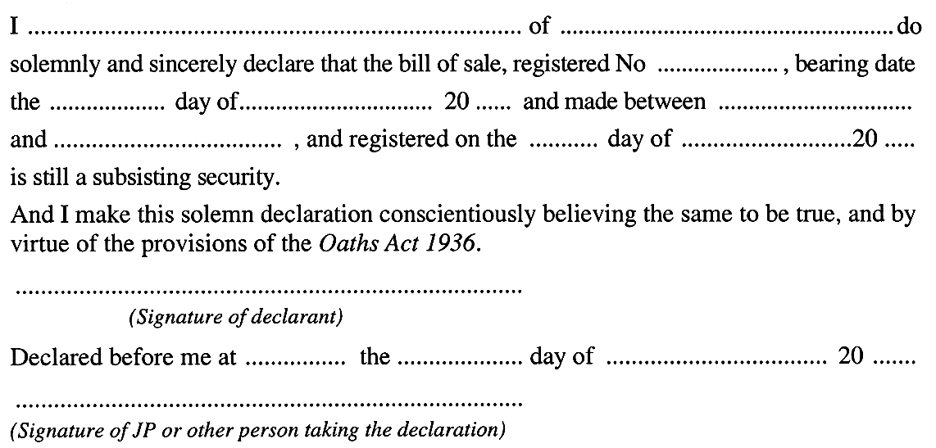
(5) The Registrar must endorse a memorandum of every renewal of the registration of a bill of sale on the original of that bill of sale filed in the registry, and on the duplicate thereof, if produced to him or her.
(6) This section does not apply to—
(a) any registered mortgage of stock as defined in the Stock Mortgages and Wool Liens Act 1924; or
(b) any registered agreement conferring a preferable lien on wool.
(7) An extension of a bill of sale duly registered as provided in section 23 will be taken to be a renewal of the registration of that bill of sale.
(8) A renewal of registration is not necessary by reason only of the transfer or assignment of a bill of sale.
(9) The fees payable in respect of the preparation, filing and endorsement of the renewal of the registration of a bill of sale are payable by the grantor, and if the grantee or any other person pays them, he or she may recover them from the grantor.
19B—Power of Court to extend time for renewal
Where—
(a) a bill of sale is not renewed within the prescribed time; and
(b) the Supreme Court, on the application of the grantee or the holder of the bill of sale or of any other person interested, is satisfied that the failure to renew the bill of sale within the prescribed time was accidental or that on other grounds it is just and equitable to grant relief,
the Supreme Court may, on such terms and conditions as the Court thinks just, by order, extend the time for renewal for such period as is specified in the order.
19D—Destruction of old bills of sale
(1) The Registrar may destroy any document kept in the Registrar's office and being—
(a) the original or duplicate of a bill of sale which has been discharged or has become void by reason of the non-renewal of its registration; or
(b) a memorial filed under the Act No. 8 of 1841–42 in respect of any bill of sale; or
(c) an index or other record of any bill of sale or memorial which the Registrar is by this section authorised to destroy.
(2) A bill of sale registered after the commencement of the Bills of Sale Act Amendment Act 1940, must not be destroyed earlier than five years after it is discharged or the registration of it becomes void.
19E—Bills of sale registered after expiry of registration of prior bill of sale
If a bill of sale over any chattels is registered between the time when the registration of a prior bill of sale over the same chattels became void under section 19A and the time when that registration was renewed under section 19B, the bill of sale first mentioned is entitled to priority over the prior bill of sale.
20—Form of transfer of bill of sale
A transfer or assignment of a registered bill of sale may be made by endorsement on the duplicate in the form of Schedule 5, or by separate instrument.
21—Bill of sale may be extended, varied or corrected
(1) An extension of time for the repayment of money secured by a bill of sale, or any other variation, or any correction, of a bill of sale, may be effected before the registration commencement time by endorsement on the duplicate, or by separate instrument, in either case signed by the parties or, where the bill is held on joint account, by the grantor or grantors and one or more of the grantees.
(2) An extension by endorsement under subsection (1) may be effected by endorsing on the duplicate the word "Extended", which will mean an extension for a further period of one year of the time for repayment but otherwise upon the terms provided in the bill of sale.
(3) Subsection (2) does not limit the manner in which an extension may be effected by endorsement.
(4) An extension of time, or any other variation, or any correction, of a bill of sale effected before the registration commencement time continues to have effect after that time.
22—Discharge
A bill of sale, or personal chattels comprised in a bill of sale, may be discharged or partially discharged by endorsement on the duplicate in the form of Schedule 4, or by separate instrument, in either case signed by the grantee or grantees or, where the bill of sale is held on joint account, by one or more of the grantees.
23—Registration of dealings with registered bills of sale
(1) Subject to subsection (1a), the Registrar must, upon the application of a party or holder of a registered bill of sale or any other person interested, register any dealing with the bill of sale.
(1a) A dealing with a bill of sale is not to be registered under this Act following the registration commencement time.
(2) An application under subsection (1)—
(a) may be made orally or, if the Registrar so requires, must be in writing in such form as the Registrar may require; and
(b) must be accompanied by the duplicate bill of sale; and
(c) must be supported by such evidence and other documents (if any) as the Registrar may require.
(3) The Registrar must register the dealing with the bill of sale by entering particulars of the dealing on the original bill of sale (including, in the case of an extension, the date and hour of the entry) and authenticating the entry by the Registrar's seal and signature.
(4) Where a dealing with a bill of sale is effected by separate instrument and registered under this section, the Registrar must, upon application, file the separate instrument or a duplicate of the separate instrument in the registry.
(5) Where a discharge is registered under this section and the discharge is for the whole of the money secured by the bill of sale, the Registrar must retain the duplicate bill of sale and file it in the registry.
(6) Where the Registrar is satisfied, on the basis of such evidence as the Registrar requires, that the duplicate bill of sale has been lost or destroyed the Registrar—
(a) may permit a dealing with the bill of sale to be effected by endorsement on the original bill of sale; and
(b) may dispense with the requirement that the duplicate bill of sale be produced.
24—Index to be kept by Registrar
The Registrar must keep an alphabetical index of the names of every grantor and grantee of a bill of sale, together with the reference to the registrations.
25—Omissions and errors in the registry may be corrected
The Registrar, upon being satisfied that any omission or error has occurred in the registration of any bill of sale, or any renewal of, or dealing with, the bill of sale, may summon the grantee or grantor, or other holder of such bill of sale, or any renewal of, or dealing with, the bill of sale, to attend before the Registrar, at such time and place as the Registrar directs, to show cause why the error or omission should not be corrected, and in case the grantee or grantor does not attend, or if he or she attends, and the Registrar is satisfied that the error or omission ought to be corrected, then the Registrar must (unless prohibited by the Supreme Court, or a Judge of the Supreme Court) proceed to make the necessary correction.
26—In case of variance, original to prevail
Whenever there is any difference or variation between the contents of an original bill of sale and of the duplicate, the original prevails.
27—Search allowed
Every person has access to any bill of sale filed in the registry, for the purpose of inspection, during the hours and upon the days appointed for search.

Part 4—Disposition of chattels in case of insolvency or distress
28—Bills of sale to be void in certain circumstances
(1) Every bill of sale which has not been registered within the prescribed time, or within any extended time allowed under this Act, is void, as against—
(a) the Official Receiver or the trustee in insolvency of the grantor;
(b) the trustee of the estate of the grantor under any statutory assignment for the benefit of his or her creditors,
so far as regards the property in or right to the possession of any personal chattels comprised in the bill of sale which within three months before the insolvency, or the meeting of creditors at which the resolution for the assignment was passed, are in the possession, or apparent possession, of the grantor, and is void as against all sheriff's officers and other persons seizing any personal chattels comprised in such bill of sale in the execution of the process of any court against the goods of the grantor, and all judgment creditors on behalf of whom such process is executed, so far as regards the property in any such personal chattels as at the time of such seizure are in the possession or apparent possession of the grantor.
(1a) Until the expiration of the period allowed for registration, every bill of sale will be taken to have been registered within that period.
(2) A bill of sale that constitutes a goods mortgage to which the National Credit Code applies is not rendered void as against any person under subsection (1) by reason of the fact that it is not registered.
(3) A bill of sale that constitutes a registered security interest within the meaning of the Goods Securities Act 1986, is not rendered void as against any person under subsection (1) by reason of the fact that it is not registered under this Act.
(4) In this section—
National Credit Code means the National Credit Code in Schedule 1 to the National Consumer Credit Protection Act 2009 of the Commonwealth.
29—Bill of sale valid security for further advance
Where any bill of sale is given as security wholly or partly for a contemporaneous or further advance, it will, subject to the provisions of this Act, be a valid security to the extent of the advance made at the time of, and subsequently to, the making of the bill of sale.
30—Distress for rates may be levied on goods comprised in bill of sale
A bill of sale does not protect the personal chattels to which it applies against any distress for any rates or taxes payable by the owner or occupier of any land under any Act.
31—Distress not to be levied against goods in bill of sale except for a limited amount
No distress for any rent made and levied upon any personal chattels comprised in any duly registered bill of sale will be available except for four weeks rent where the tenement is let by the week; for two terms of payment (but not exceeding three months) where the tenement is let for any other term less than six months; or for twelve months rent where the tenement is let for any longer term, unless the landlord pays off the sum of money owing on the bill of sale.

Part 6—Miscellaneous provisions
34—Fees
It is lawful for the Registrar to demand and receive such fees as may be prescribed by regulation for the purposes of this Act, and those fees must be accounted for by the Registrar and paid into the Consolidated Account.
36—Goods not to be sold until five days after seizure
Personal chattels (except those of a perishable nature) must not be sold until five days after seizure under a bill of sale.
37—Fraudulently disposing of goods
Any person who conceals, sells, pawns, kills, or destroys any personal chattels comprised in any bill of sale, with intent to deprive the grantee of his or her security, is guilty of an offence.
Penalty: Division 5 imprisonment.
38—False declaration to be perjury
Any person guilty of making a false declaration concerning any matter or procedure to be done in pursuance of this Act is guilty of perjury.
Penalty: Division 5 imprisonment.
38A—Paper to be used for instruments
(1) Subject to this section, every bill of sale or other instrument lodged with the Registrar for registration or filing in the registry must be on paper of a size and kind prescribed by regulation.
(2) The Registrar may dispense with the requirement to comply with subsection (1) in such circumstances as the Registrar thinks fit.
38B—Minister may discharge bill of sale in certain circumstances
(1) Subject to subsection (1aa), if all money secured by a bill of sale has been paid by the grantor and the grantee—
(a) is dead; or
(b) cannot be found; or
(c) is incapable of executing a discharge of the bill of sale; or
(d) has, in the opinion of the Minister, refused to execute a discharge of the bill of sale without sufficient reason,
the Minister may execute a discharge of the bill of sale.
(1aa) The Minister may not execute a discharge of a bill of sale after the registration commencement time.
(1a) The Minister must not execute a discharge of a bill of sale pursuant to subsection (1)(d) unless—
(a) the Registrar-General has sent by certified mail to the grantee at his or her last known address a notice stating that the Minister proposes to discharge the bill of sale pursuant to subsection (1)(d) at the expiration of the prescribed period unless the grantee establishes to the satisfaction of the Minister that he or she is justified in refusing to execute a discharge of the bill of sale; and
(b) the prescribed period has elapsed since the notice was sent.
(1b) The prescribed period is—
(a) in a case where the notice is addressed to the grantee within Australia—one month;
(b) in any other case—two months.
(2) Subject to subsection (2a), the Minister may receive money on behalf of a grantee, or the estate of a grantee, who—
(a) is dead; or
(b) cannot be found; or
(c) is incapable of executing a discharge of the bill of sale; or
(d) has, in the opinion of the Minister, refused to accept payment under the bill of sale without sufficient reason,
and any money so received will, for the purposes of this section and the bill of sale, be taken to have been paid to the grantee.
(2a) The Minister may not receive money under subsection (2) after the registration commencement time.
(3) Any money received by the Minister under subsection (2) must be held by the Minister upon trust for the grantee or other person entitled to it.
(4) Subject to subsection (5), a discharge of a bill of sale executed under this section has the same effect as a discharge executed by the grantee.
(5) A discharge of a bill of sale executed under this section does not operate as a discharge of the personal covenants of the bill of sale.
39—Regulations
The Governor may make such regulations as are contemplated by this Act, or as are necessary or expedient for the purposes of this Act.
41—Act not to apply to chattels taken and kept by grantee within 21 days
This Act does not apply to any bill of sale where the grantee takes the personal chattels to which the bill of sale applies out of the possession, or apparent possession, of the grantor within 21 days of the date of the bill of sale, and keeps possession of them.

Part 7—Provisions relating to PPS Act
42—Certain provisions of Act to cease to have effect
(1) The following provisions of this Act will cease to have effect at the registration commencement time:
(a) section 7;
(b) sections 9 and 10;
(c) section 13;
(d) sections 17 to 18 (inclusive);
(e) section 19B;
(f) sections 19E and 20;
(g) section 22;
(h) the provisions of Part 4;
(i) section 36;
(j) section 37.
(2) Any proceedings on foot before the Supreme Court under section 17B or 19B at the registration commencement time are discontinued at the registration commencement time by force of this subsection.
43—Provision of information to Commonwealth
(1) The Registrar may provide the PPS Registrar, or any other officer of the Commonwealth, with such information concerning bills of sale registered under this Act, and any other information recorded by the Registrar in connection with registration under this Act, as the Registrar considers appropriate in order to assist the Commonwealth in establishing the PPS Register.
(2) The Registrar may provide the information referred to in subsection (1) in such form (including by means of electronic data or in a form approved for the purposes of the PPS Act) as the Registrar considers appropriate.
(3) In this section—
PPS Register means the Personal Property Securities Register established under the PPS Act;
PPS Registrar means the Registrar of Personal Property Securities under the PPS Act.
44—Immunity
The State, or an officer, employee or agent of the State, does not incur liability for anything done or omitted to be done in good faith by the State, officer, employee or agent—
(a) in the exercise of a power or the discharge of a duty under section 43; or
(b) in the reasonable belief that the act or omission was in the exercise of a power or the discharge of a duty under section 43.
45—Registrar may refuse to exercise functions
(1) The Registrar may refuse to exercise a function under this Act during the pre-PPS transitional period.
(2) Without limiting subsection (1), the Registrar may refuse to exercise a function during the pre-PPS transitional period in relation to a matter that was not finally determined or concluded immediately before the commencement of that period.
(3) In this section—
migration time has the same meaning as in the PPS Act;
pre-PPS transitional period means the period—
(a) commencing at the migration time or such earlier time as may be prescribed by the regulations; and
(b) ending at the registration commencement time.
46—Registrar may dispose of certain documents
The Registrar may, following the registration commencement time, destroy or otherwise dispose of any bill of sale kept in the Registrar's office, or any document or record kept in connection with such a bill of sale, if, in the opinion of the Registrar, retention of the bill of sale or other document or record would serve no useful purpose.
47—Regulations
(1) The Governor may make regulations containing provisions of a savings or transitional nature—
(a) consequent on the enactment of the Personal Property Securities (Commonwealth Powers) Act 2009 or on the commencement of specified provisions of that Act; or
(b) relevant to the interaction between this Act and the PPS Act.
(2) The Governor may, by regulation—
(a) provide that this Act is to apply to prescribed bills of sale, or bills of sale relating to property of a prescribed kind, as if it had not been amended by the Statutes Amendment (Personal Property Securities) Act 2011 (the amending Act) or as if specified amendments made by the amending Act had not been made; and
(b) make any consequential provision necessary in connection with a regulation under paragraph (a).
(3) The Registrar may provide such information concerning bills of sale, or other information recorded by the Registrar in connection with registration under this Act, as the Registrar considers appropriate to the person responsible for maintaining a register under another Act if the information is provided in accordance with an arrangement entered into by the Minister with the Minister responsible for the administration of the other Act.

Part 8—Repeal of Act
48—Repeal of Act
(1) After the registration commencement time, the Governor may, by proclamation, fix a date for the repeal of this Act.
(2) On the date fixed under subsection (1), this Act is repealed.

Schedule 1—Bill of sale
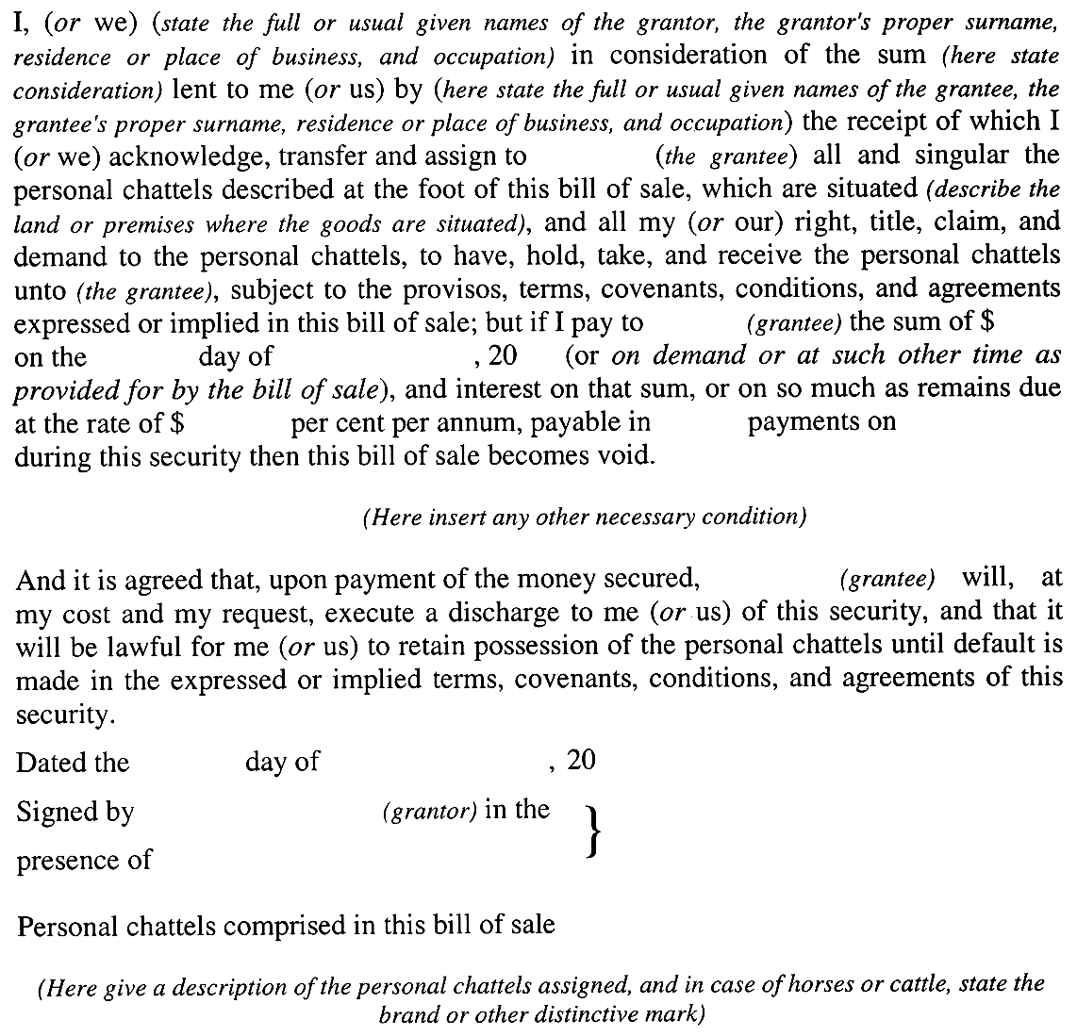

Schedule 3—Certificate of registration to be endorsed by Registrar on each bill of sale
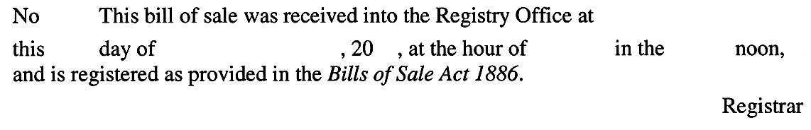

Schedule 4—Discharge of bill of sale
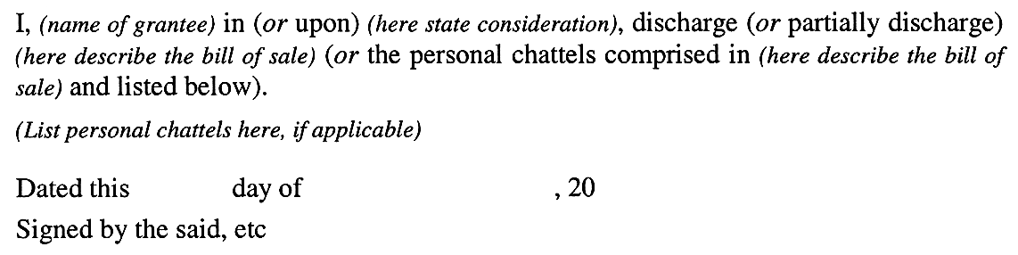

Schedule 5—Transfer of bill of sale
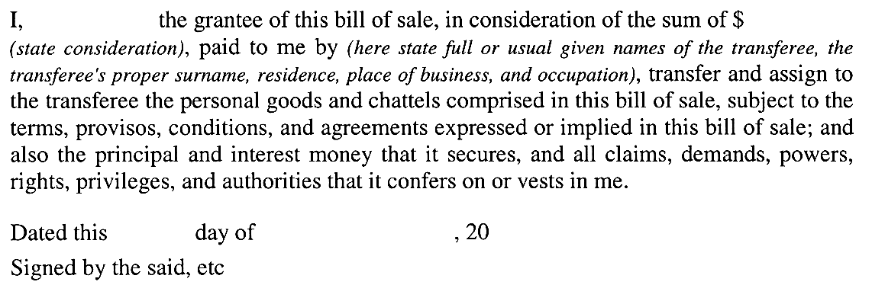

Legislative history
Notes
• Please note—References in the legislation to other legislation or instruments or to titles of bodies or offices are not automatically updated as part of the program for the revision and publication of legislation and therefore may be obsolete.
• Earlier versions of this Act (historical versions) are listed at the end of the legislative history.
• For further information relating to the Act and subordinate legislation made under the Act see the Index of South Australian Statutes or www.legislation.sa.gov.au.
Repeal of Act
The Bills of Sale Act 1886 will be repealed by proclamation.
After the registration commencement time, the Governor may, by proclamation, fix a date for the repeal of this Act: s 48.
Principal Act and amendments
New entries appear in bold.
Year | No | Title | Assent | Commencement
1886 | 389 | Bills of Sale Act 1886 | 17.11.1886 | 17.11.1886
1924 | 1649 | Stock Mortgages and Wool Liens Act 1924 | 24.12.1924 | 24.12.1924
1934 | 2168 | Statute Law Revision Act 1934 | 15.11.1934 | 15.11.1934
1934 | 2187 | Bills of Sale Act Amendment Act 1934 | 29.11.1934 | 29.11.1934
1935 | 2246 | Statute Law Revision Act 1935 | 19.12.1935 | 19.12.1935
1940 | 52 | Bills of Sale Act Amendment Act 1940 | 5.12.1940 | 5.12.1940
1970 | 35 | Bills of Sale Act Amendment Act 1970 | 3.12.1970 | 15.2.1971 (Gazette 28.1.1971 p283)
1972 | 119 | Bills of Sale Act Amendment Act 1972 | 30.11.1972 | 1.11.1973 (Gazette 6.9.1973 p1899)
1983 | 83 | Bills of Sale Act Amendment Act 1983 | 1.12.1983 | 10.5.1984 (Gazette 22.3.1984 p724)
1986 | 111 | Goods Securities Act 1986 | 18.12.1986 | Sch 1—15.6.1987 (Gazette 11.6.1987 p1492)
1987 | 25 | Bills of Sale Act Amendment Act 1987 | 16.4.1987 | 16.4.1987
1990 | 23 | Statute Law Revision Act 1990 | 26.4.1990 | Sch 3—29.6.1990 (Gazette 14.6.1990 p1606)
1994 | 59 | Criminal Law Consolidation (Felonies and Misdemeanours) Amendment Act 1994 | 27.10.1994 | 1.1.1995 (Gazette 8.12.1994 p1942)
1996 | 67 | Statutes Amendment (Attorney-General's Portfolio) Act 1996 | 15.8.1996 | s 6—17.10.1996 (Gazette 17.10.1996 p1361)
2008 | 12 | Statutes Amendment (Real Property) Act 2008 | 8.5.2008 | Pt 2 (s 4)—1.6.2009 (Gazette 28.5.2009 p1843)
2010 | 3 | Credit (Transitional Arrangements) Act 2010 | 24.6.2010 | Sch 1 (cl 2)—1.7.2010 (Gazette 1.7.2010 p3337)
2011 | 11 | Statutes Amendment (Personal Property Securities) Act 2011 | 14.4.2011 | Pt 3 (ss 5—17)—16.6.2011 (Gazette 16.6.2011 p2610)
Provisions amended since 3 February 1976
• Legislative history prior to 3 February 1976 appears in marginal notes and footnotes included in the consolidation of this Act contained in Volume 1 of The Public General Acts of South Australia 1837-1975 at page 509.
New entries appear in bold.
Entries that relate to provisions that have been deleted appear in italics.
Provision | How varied | Commencement
Long title | substituted by 23/1990 s 3(1) (Sch 3) | 29.6.1990
Pt 1 | heading inserted by 23/1990 s 3(1) (Sch 3) | 29.6.1990
s 2
s 2(1) | s 2 amended and redesignated as s 2(1) by 23/1990 s 3(1) (Sch 3) | 29.6.1990
bill of sale | amended by 23/1990 s 3(1) (Sch 3) | 29.6.1990
business day | inserted by 11/2011 s 5(1) | 16.6.2011
contemporaneous advance | amended by 23/1990 s 3(1) (Sch 3) | 29.6.1990
dealing | inserted by 83/1983 s 3 | 10.5.1984
grantee | amended by 23/1990 s 3(1) (Sch 3) | 29.6.1990
grantor | amended by 23/1990 s 3(1) (Sch 3) | 29.6.1990
personal chattels | amended by 23/1990 s 3(1) (Sch 3) | 29.6.1990
PPS Act | inserted by 11/2011 s 5(2) | 16.6.2011
prescribed | deleted by 23/1990 s 3(1) (Sch 3) | 29.6.1990
registration commencement time | inserted by 11/2011 s 5(3) | 16.6.2011
registry | amended by 23/1990 s 3(1) (Sch 3) | 29.6.1990
trade machinery | substituted by 23/1990 s 3(1) (Sch 3) | 29.6.1990
s 2(2) | s 2 second sentence amended and redesignated as s 2(2) by 23/1990 s 3(1) (Sch 3) | 29.6.1990
s 3 | amended by 83/1983 s 4 | 10.5.1984
 | deleted by 23/1990 s 3(1) (Sch 3) | 29.6.1990
Pt 2 | heading substituted by 23/1990 s 3(1) (Sch 3) | 29.6.1990
ss 7 and 8 | amended by 23/1990 s 3(1) (Sch 3) | 29.6.1990
s 9
s 9(1) | s 9 amended by 83/1983 s 5 | 10.5.1984
 | s 9 amended and redesignated as s 9(1) by 23/1990 s 3(1) (Sch 3) | 29.6.1990
s 9(2) | s 9 second sentence redesignated as s 9(2) by 23/1990 s 3(1) (Sch 3) | 29.6.1990
s 10 | substituted by 23/1990 s 3(1) (Sch 3) | 29.6.1990
s 10A
s 10A(1) | s 10A amended and redesignated as s 10A(1) by 23/1990 s 3(1) (Sch 3) | 29.6.1990
 | amended by 11/2011 s 6 | 16.6.2011
s 10A(2) | inserted by 23/1990 s 3(1) (Sch 3) | 29.6.1990
s 11 | amended by 23/1990 s 3(1) (Sch 3) | 29.6.1990
 | amended by 11/2011 s 7 | 16.6.2011
s 11A | inserted by 12/2008 s 4 | 1.6.2009
s 11A(1) | amended by 11/2011 s 8(1) | 16.6.2011
s 11A(1a) | inserted by 11/2011 s 8(2) | 16.6.2011
s 11A(2) | amended by 11/2011 s 8(3) | 16.6.2011
s 12 | amended by 23/1990 s 3(1) (Sch 3) | 29.6.1990
 | amended by 11/2011 s 9 | 16.6.2011
s 12A | amended by 23/1990 s 3(1) (Sch 3) | 29.6.1990
 | amended by 11/2011 s 10 | 16.6.2011
s 12B | inserted by 83/1983 s 6 | 10.5.1984
 | amended by 23/1990 s 3(1) (Sch 3) | 29.6.1990
 | amended by 11/2011 s 11 | 16.6.2011
s 13 | amended by 83/1983 s 7 | 10.5.1984
 | amended by 23/1990 s 3(1) (Sch 3) | 29.6.1990
s 14 | deleted by 83/1983 s 8 | 10.5.1984
Pt 3
s 15
s 15(1) | s 15 amended by 23/1990 s 3(1) (Sch 3) | 29.6.1990
 | s 15 amended and redesignated as s 15(1) by 11/2011 s 12(1), (2) | 16.6.2011
s 15(2) | inserted by 11/2011 s 12(2) | 16.6.2011
s 17 | substituted by 83/1983 s 9 | 10.5.1984
 | amended by 23/1990 s 3(1) (Sch 3) | 29.6.1990
s 17A | amended by 83/1983 s 10 | 10.5.1984
 | amended by 23/1990 s 3(1) (Sch 3) | 29.6.1990
s 17B | inserted by 83/1983 s 11 | 10.5.1984
s 18 | amended by 83/1983 s 12 | 10.5.1984
 | amended by 23/1990 s 3(1) (Sch 3) | 29.6.1990
s 19 | amended by 23/1990 s 3(1) (Sch 3) | 29.6.1990
s 19A
s 19A(1) | deleted by 23/1990 s 3(1) (Sch 3) | 29.6.1990
s 19A(2) | amended by 23/1990 s 3(1) (Sch 3) | 29.6.1990
s 19A(2a) | inserted by 11/2011 s 13 | 16.6.2011
s 19A(3)—(6) | amended by 23/1990 s 3(1) (Sch 3) | 29.6.1990
s 19A(7) | amended by 83/1983 s 13 | 10.5.1984
 | amended by 23/1990 s 3(1) (Sch 3) | 29.6.1990
s 19A(8) and (9) | amended by 23/1990 s 3(1) (Sch 3) | 29.6.1990
s 19B | substituted by 83/1983 s 14 | 10.5.1984
s 19C | deleted by 83/1983 s 14 | 10.5.1984
s 19D
s 19D(1) | s 19D amended and redesignated as s 19D(1) by 23/1990 s 3(1) (Sch 3) | 29.6.1990
s 19D(2) | s 19D provision amended and redesignated as s 19D(2) by 23/1990 s 3(1) (Sch 3) | 29.6.1990
s 19E | amended by 23/1990 s 3(1) (Sch 3) | 29.6.1990
s 20 | amended by 83/1983 s 15 | 10.5.1984
 | amended by 23/1990 s 3(1) (Sch 3) | 29.6.1990
s 21 | substituted by 83/1983 s 16 | 10.5.1984
s 21
s 21(1) | amended by 23/1990 s 3(1) (Sch 3) | 29.6.1990
 | amended by 11/2011 s 14(1) | 16.6.2011
s 21(2) | amended by 23/1990 s 3(1) (Sch 3) | 29.6.1990
s 21(4) | inserted by 11/2011 s 14(2) | 16.6.2011
s 22 | substituted by 83/1983 s 16 | 10.5.1984
s 23 | substituted by 83/1983 s 16 | 10.5.1984
 | amended by 23/1990 s 3(1) (Sch 3) | 29.6.1990
s 23(1) | amended by 11/2011 s 15(1) | 16.6.2011
s 23(1a) | inserted by 11/2011 s 15(2) | 16.6.2011
s 24 | amended by 23/1990 s 3(1) (Sch 3) | 29.6.1990
s 25 | amended by 83/1983 s 17 | 10.5.1984
 | amended by 23/1990 s 3(1) (Sch 3) | 29.6.1990
ss 26 and 27 | amended by 23/1990 s 3(1) (Sch 3) | 29.6.1990
Pt 4
s 28
s 28(1) | amended by 83/1983 s 18(a), (b) | 10.5.1984
 | amended by 23/1990 s 3(1) (Sch 3) | 29.6.1990
 | s 28(1) second proviso deleted by 83/1983 s 18(c) | 10.5.1984
s 28(1a) | s 28(1) first proviso amended and redesignated as s 28(1a) by 23/1990 s 3(1) (Sch 3) | 29.6.1990
s 28(2) | amended by 23/1990 s 3(1) (Sch 3) | 29.6.1990
 | amended by 67/1996 s 6 | 17.10.1996
 | substituted by 3/2010 Sch 1 cl 2(1) | 1.7.2010
s 28(3) | inserted by 111/1986 Sch 1 | 15.6.1987
s 28(4) | inserted by 3/2010 Sch 1 cl 2(2) | 1.7.2010
ss 29—31 | amended by 23/1990 s 3(1) (Sch 3) | 29.6.1990
Pt 5 | heading deleted by 83/1983 s 19 | 10.5.1984
s 33 | deleted by 23/1990 s 3(1) (Sch 3) | 29.6.1990
Pt 6
s 34 | amended by 23/1990 s 3(1) (Sch 3) | 29.6.1990
s 35 | deleted by 83/1983 s 20 | 10.5.1984
s 36 | substituted by 23/1990 s 3(1) (Sch 3) | 29.6.1990
s 37 | amended by 23/1990 s 3(1) (Sch 3) | 29.6.1990
 | amended by 59/1994 Sch 2 | 1.1.1995
s 38 | amended by 23/1990 s 3(1) (Sch 3) | 29.6.1990
s 38A | inserted by 83/1983 s 21 | 10.5.1984
s 38A(2) | amended by 23/1990 s 3(1) (Sch 3) | 29.6.1990
s 38B | inserted by 83/1983 s 21 | 10.5.1984
s 38B(1) | substituted by 25/1987 s 2(a) | 16.4.1987
 | amended by 11/2011 s 16(1) | 16.6.2011
s 38B(1aa) | inserted by 11/2011 s 16(2) | 16.6.2011
s 38B(1a) and (1b) | inserted by 25/1987 s 2(a) | 16.4.1987
s 38B(2) | amended by 25/1987 s 2(b), (c) | 16.4.1987
 | amended by 23/1990 s 3(1) (Sch 3) | 29.6.1990
 | amended by 11/2011 s 16(3) | 16.6.2011
s 38B(2a) | inserted by 11/2011 s 16(4) | 16.6.2011
s 38B(3) | amended by 25/1987 s 2(b) | 16.4.1987
 | amended by 23/1990 s 3(1) (Sch 3) | 29.6.1990
s 38B(4) and (5) | amended by 23/1990 s 3(1) (Sch 3) | 29.6.1990
s 39 | substituted by 23/1990 s 3(1) (Sch 3) | 29.6.1990
s 40 | deleted by 23/1990 s 3(1) (Sch 3) | 29.6.1990
s 41 | amended by 23/1990 s 3(1) (Sch 3) | 29.6.1990
s 42 | deleted by 23/1990 s 3(1) (Sch 3) | 29.6.1990
Pt 7 | inserted by 11/2011 s 17 | 16.6.2011
Pt 8 | inserted by 11/2011 s 17 | 16.6.2011
Heading preceding Sch 1 | deleted by 23/1990 s 3(1) (Sch 3) | 29.6.1990
Sch 1 | amended by 23/1990 s 3(1) (Sch 3) | 29.6.1990
Sch 2 | deleted by 83/1983 s 22 | 10.5.1984
Sch 4 | substituted by 83/1983 s 23 | 10.5.1984
 | amended by 23/1990 s 3(1) (Sch 3) | 29.6.1990
Sch 5 | amended by 23/1990 s 3(1) (Sch 3) | 29.6.1990
Sch 7 | deleted by 83/1983 s 24 | 10.5.1984
Historical versions
Reprint—29.6.1990
Reprint No 1—1.1.1995
Reprint No 2—17.10.1996
1.6.2009
1.7.2010

Appendix—Divisional penalties and expiation fees
At the date of publication of this version divisional penalties and expiation fees are, as provided by section 28A of the Acts Interpretation Act 1915, as follows:

Division | Maximum imprisonment | Maximum fine | Expiation fee
1 | 15 years | $60 000 | —
2 | 10 years | $40 000 | —
3 | 7 years | $30 000 | —
4 | 4 years | $15 000 | —
5 | 2 years | $8 000 | —
6 | 1 year | $4 000 | $300
7 | 6 months | $2 000 | $200
8 | 3 months | $1 000 | $150
9 | – | $500 | $100
10 | – | $200 | $75
11 | – | $100 | $50
12 | – | $50 | $25
Note: This appendix is provided for convenience of reference only.

